**GITHUB – Common Usage**

1. **Syncing with Repository**
2. In Anaconda prompt move to the directory of the repository
3. Make sure you are in the master branch

You can do this by typing:

* git branch

To move into the master branch type:

* git checkout master

1. Once in master branch type the following commands:

* git fetch upstream
* git merge upstream/master
* git push origin master

1. **Updating the Repository (Do this before making changes to your local repository)**
2. In the directory where the repository is placed move to master branch by typing

* git checkout master

1. Create a branch (say training_oct_2019)

* git checkout -b training_oct_2019

1. Now make any changes required in your local repository. After you are done you can commit these changes to your online repository with a small description of what you have changed within the quotes ” ” and push these changes to your branch to your online repository by typing (see Note 4 below),

* git commit -a -m “making changes to the repository for training oct 2019”
* git push origin training_oct_2019

1. **Important Note:** Sometimes the files that are changed are not “tracked” by github and need to be included into the repository. In order to get the information of the tracked and untracked files type,

* git status

To “add” files to be tracked we type,

* git add <filename>

To remove files from being tracked we type,

* git rm <filename>

1. The person managing the main repository would get a merge request which is then merged onto the main repository as follows:-

In the example show below the branch is called training_oct_2019 and the repository has gotten a “pull request” shown in the green button

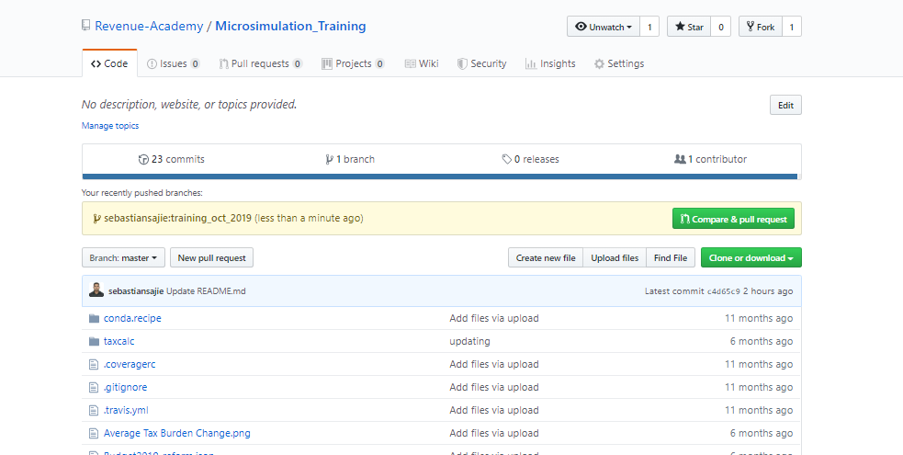

1. On clicking the green button “Compare & pull request”, it opens up a page where the “pull request is sent”. The text in the commit command above “making changes to the repository for training oct 2019” is the default subject. A short description about what changes are being made can then be entered into the comment section.

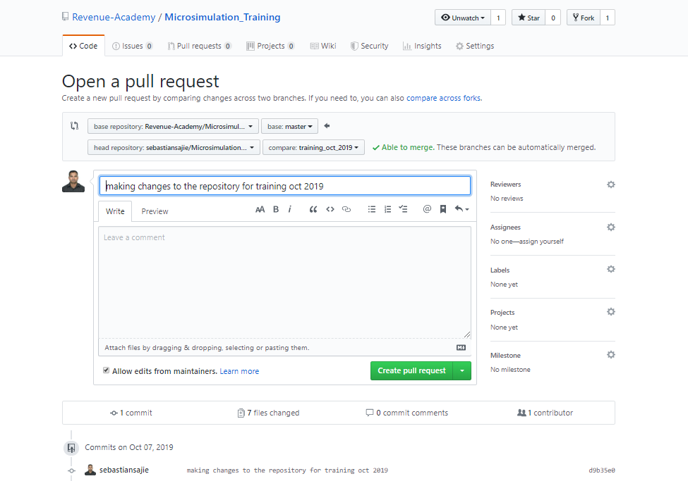

1. Shown below is a short description of the “pull request”. We then click on the green button “Create pull request”.

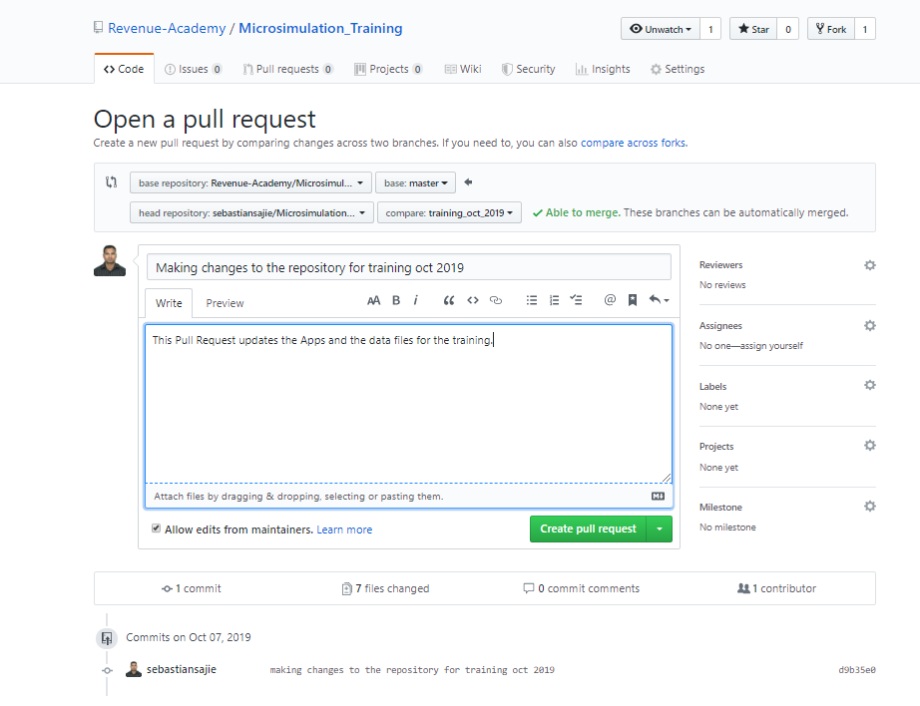

1. The **Owner** of the Repository would then get a request to “Merge” the pull request onto the main repository. The Owner clicks on the green button “Merge pull request” to merge the changes onto the main repository.

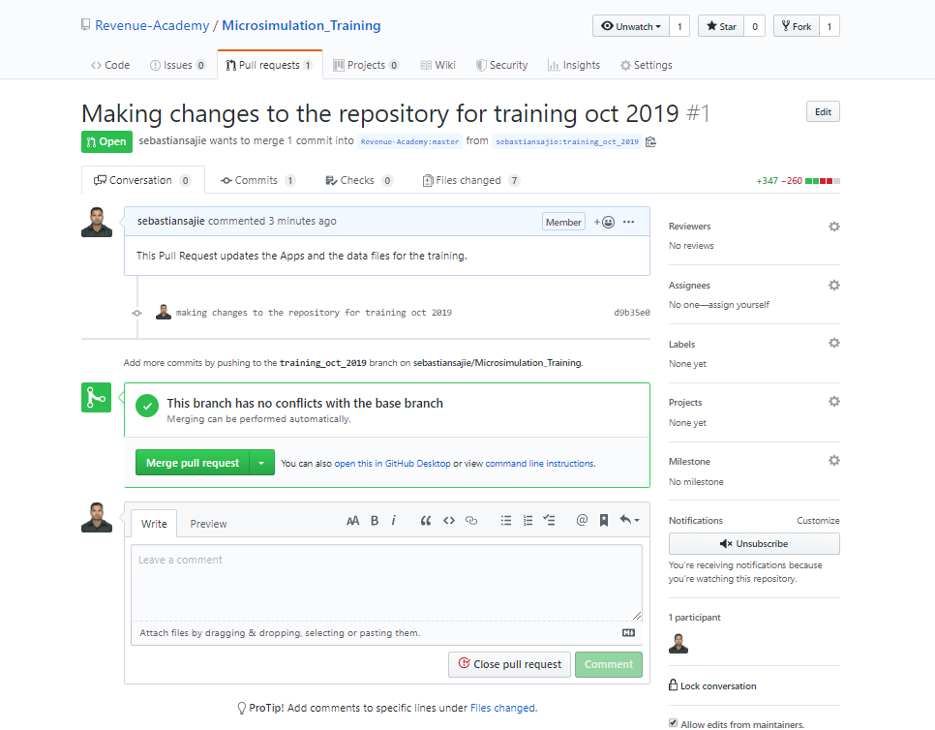

1. **Syncing Branch with updates of Master Branch**

When you are working on a branch and want to incorporate changes made to the master into the branch, the go into the branch ‘amending_repo’ and merge the changes as follows:-

1. git checkout amending_repo
2. git merge origin/master
3. **Check the status of your Branch (incl. master) as compared to the Repository**
4. git branch -vv